Security control review

Owner: Ho Yeung, Lee

Classification: Secret

FIPS-199 SC administrative information = {(confidentiality, HIGH), (integrity, LOW), (availability, LOW)}

Standard: NIST 800-53

Availability of security testing resources

Criticality of the systems and applications protected by the tested controls Sensitivity of information contained on tested systems and applications

Likelihood of a technical failure of the mechanism implementing the control Likelihood of a misconfiguration of the control that would jeopardize security

Risk that the system will come under attack

Rate of change of the control configuration

Other changes in the technical environment that may affect the control

performance Difficulty and time required to perform a control test

Impact of the test on normal business operations

**Appendix**

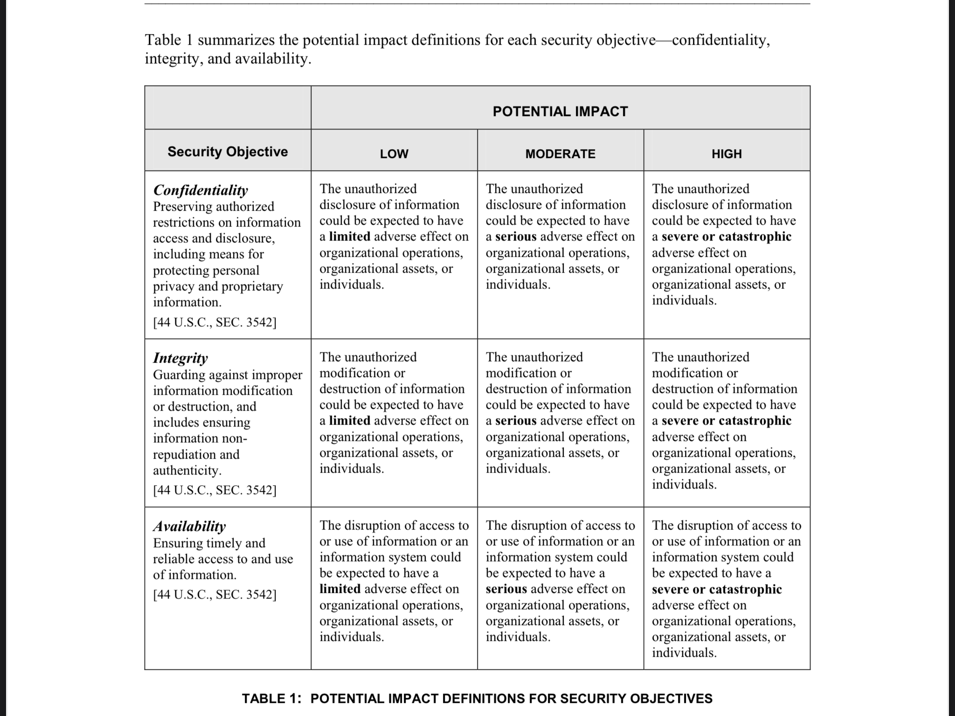**FIPS-199**